Translational Principle, Abiding.

This is the day the Lord has made, let us rejoice and be glad in it.

Psalm 91
He who dwells in the secret place of the Most High
Shall abide under the shadow of the Almighty.
I will say of the LORD, “He is my refuge and my fortress;
My God, in Him I will trust.”
Surely He shall deliver you from the snare of the fowler
And from the perilous pestilence.
He shall cover you with His feathers,
And under His wings you shall take refuge;
His truth shall be your shield and buckler.
You shall not be afraid of the terror by night,
Nor of the arrow that flies by day,
Nor of the pestilence that walks in darkness,
Nor of the destruction that lays waste at noonday.
A thousand may fall at your side,
And ten thousand at your right hand;
But it shall not come near you.
Only with your eyes shall you look,
And see the reward of the wicked.
Because you have made the LORD, who is my refuge,
Even the Most High, your dwelling place,
No evil shall befall you,
Nor shall any plague come near your dwelling;
For He shall give His angels charge over you,
To keep you in all your ways.
In their hands they shall bear you up,
Lest you dash your foot against a stone.
You shall tread upon the lion and the cobra,
The young lion and the serpent you shall trample underfoot.
“Because he has set his love upon Me, therefore I will deliver him;
I will set him on high, because he has known My name.
He shall call upon Me, and I will answer him;
I will be with him in trouble;
I will deliver him and honor him.
With long life I will satisfy him,
And show him My salvation.”

Thank you Ps Lakers for inviting me to share my testimony of the last six months and I hope the message will encourage my brothers on MAGH.

My name, Barry is translated into “Spear or Marksman”.

The Translation Principle has been the sharpening of the spear in 2026. This spear has taken formation since I joined MAGH four years ago.

I have become a marksman for God, honing my skills here on this platform, hitting targets for God with surgical precision. His Will orders my mind and body in flawless synchrony.

- At the start of the year on MAGH I was gifted a glimmer of the impossible by a statement being made that 2026 is to be a year without ceilings.
- The translation principle teaching has been the game changer and I can sum up my life in the teaching of Embodied Obedience.

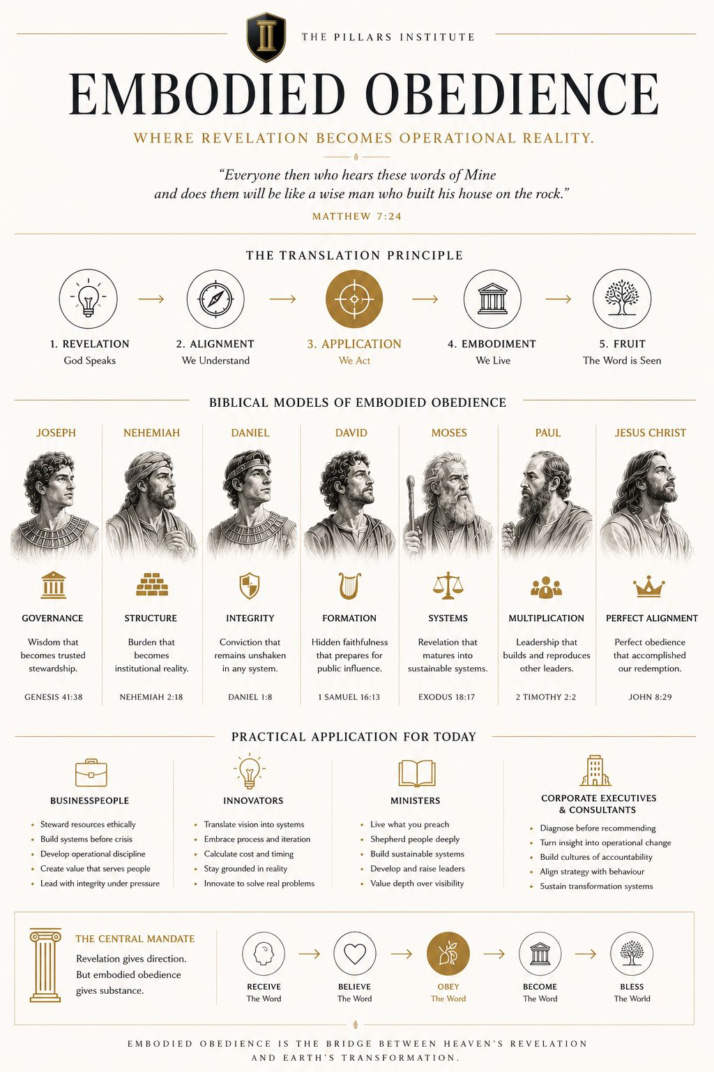

*1. What has changed?*

- The start of this year can be described by the Authority Stabilisation Engine. I was in a place where Crack Firmation was evident in every area of my life.
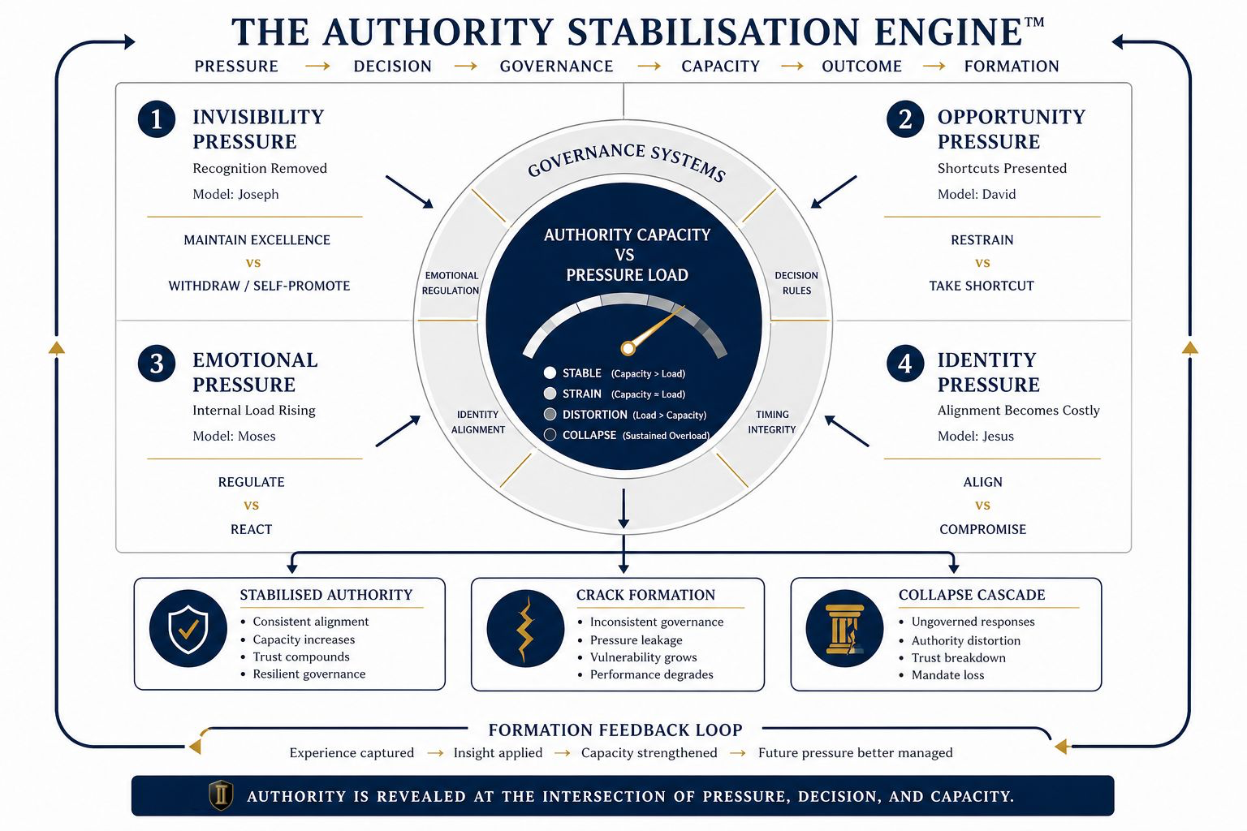
- I think less and act more because my Holy Father reveals His instructions and my only job is to obey.
- My perspective has shifted to seeing the world through the eyes of eternity and a direct result is a peace and calm that surpasses understanding.
- My priorities have aligned with God’s Will, and life has become effortless and fruitful. His Will is perfect.
- Good habits abound such as having nothing to say or add just to be heard. Patience and empathy have increased.
- Relationships have deepened in every marketplace as I can view life through other’s eyes. This has reduced my offendedness to almost negligible.
- Because I am following the Will of the Lord, I have become a greater leader through action and servitude.
- God is looking directly at me and I know that He favours me and loves me like no other. I am His special boy and He reveals Himself to me.

*2. What became flesh?*

- I am beginning to understand the nature of having a submitted and obedient posture. God moves in this space as His eyes see me and His ears are opened.
- The direct result of this is a manifestation of His Word, which becomes flesh in my life. I trust my God and He comes through every time.
- My life is filled with Divine interventions and appointments every day, so I am joyfully expectant.
- A new career being offered to me one day after I resign from my profession.
- National and international projects have opened up to me such that my cup is overflowing.
- I walk now with a sense that there are no coincidences, and everything has a purpose, even when the outcome is the opposite of expectation.
- There is no more disappointment because I know that God sees the “big picture”.
- He reveals to me as He pleases according to the trust He has in me to steward His instructions.

*3. What still resists translation?*

- I am resisting exercise and eating healthy at the time of this message. There have been no shortage of destiny helpers in this place.
- There is more submission required to produce the good, healthy habits.
- I understand the physical benefits of being healthy, though embodiment has not taken place.

*4. What must be preserved?*

- My trust in God that He is His Word and this is now etched in my heart. I am sold out to my Holy Father.
- I will preserve this, the rest of my life and encourage each man in this platform to submit to the Will of God in his life.

*5. What am I committing to steward over the next 12 months?*

- Whatever God instructs for however long as I move according to His Will in my life.
- Being the leader of my household as a loving husband and father.
- Initiating the building of a hospital in Zimbabwe and renal clinic in Uganda
- My company taking a foothold in the building industry.

Ps Lakers.

